|  |  |
| --- | --- |
|  |  |

|  |
| --- |
| Dot Plot Features Document |
|  |

# Short Description

This visual is used to display distribution using dots among multiple categories.

# Overview

Dot plot is a statistical chart consisting of data points (bubble) plotted on XY axis with the user option to view data of multiple categories. Each bubble size and color represents value and type of categories respectively. Dot plot also provides parent and child sub-categorization.

Dot plot supports selection, partial highlighting, multi selection, legends, tooltips, display different color bubble for different category, and all other default formatting options available in Power BI. User can modify bubble size, orientation of chart, X-axis and Y-axis text, background and start the axis from a specified value.

# Example

Assume that the CEO of a company wants to know total revenue of all the products of his company.

So, he will just enter the Product in Axis field and ‘Total Revenue’ in the value field and will get list of all Products with respective Total Revenue.

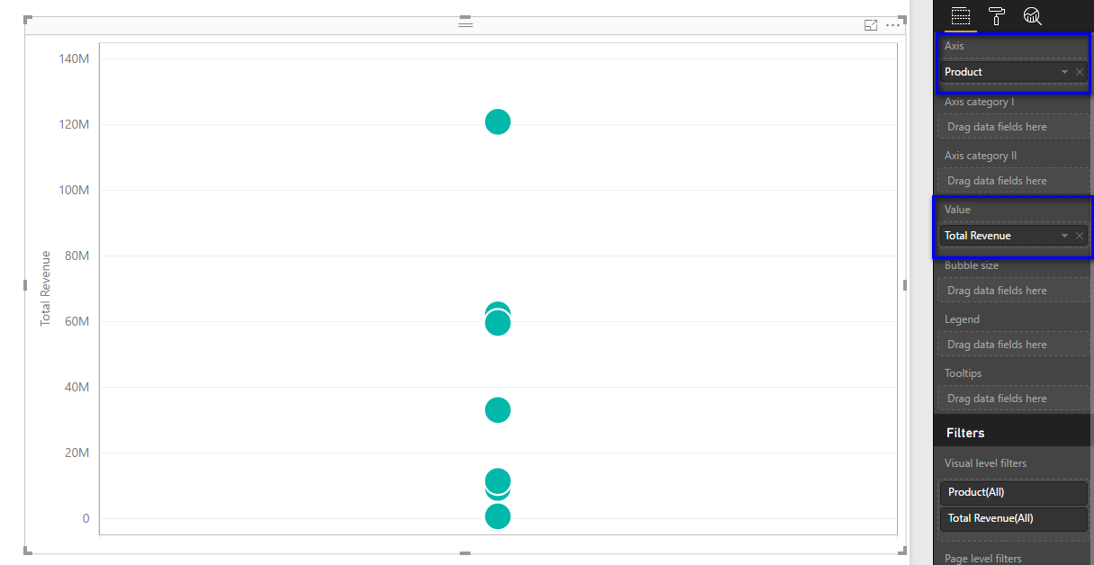

But from this he cannot understand how much revenue has been generated in different quarters relative to each other. This can be found by dragging ‘Quarter’ in Axis Category I field.

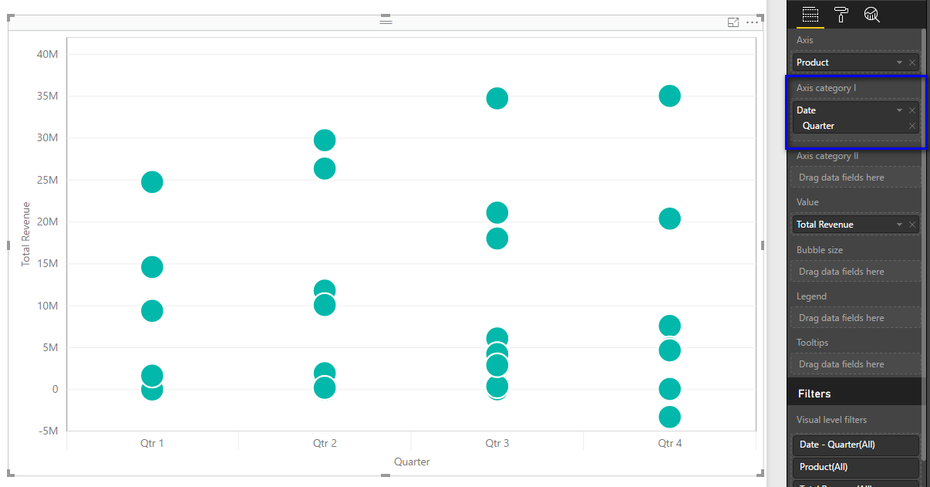

For even deeper analysis, he wants to know which products are profitable and which are non-profitable. To know this, he selects ‘Profitable?’ to ‘Legend’ field.

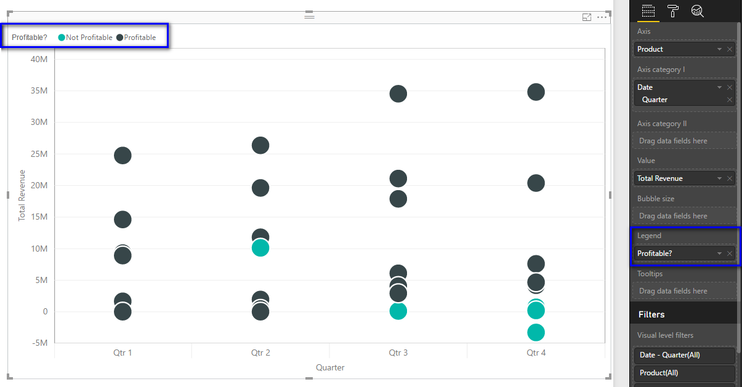

For analyzing every individual value which is not displayed from the graph, Tooltips can be added. Suppose now the CEO wants to know, what is the ‘state’ of a product, say Fama then those value can be added in tooltips.

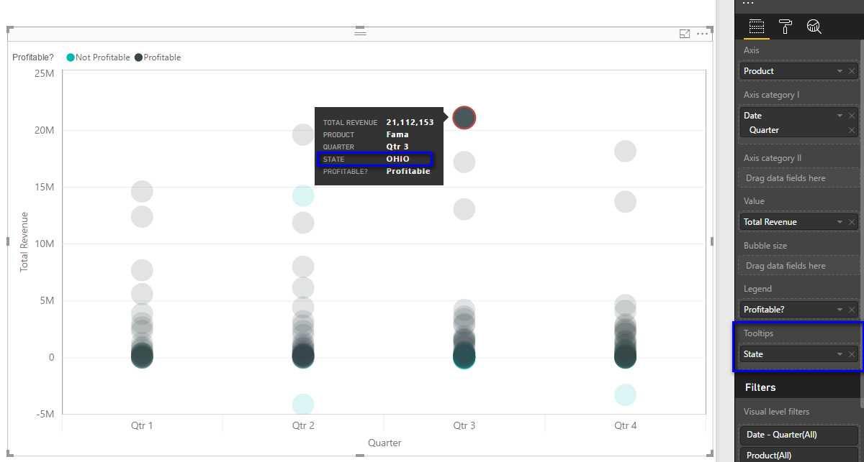

Now, if he wants to see Gross margin of each product, then he can drag Gross Margin value in Bubble size field. Bigger the bubble, higher is the Gross Margin value.

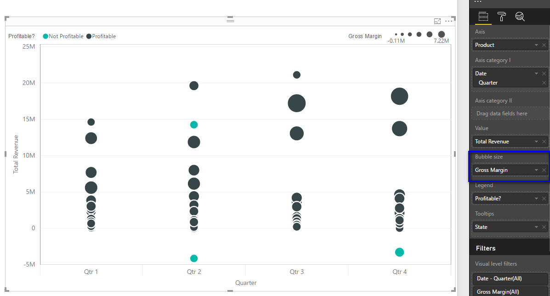

Now if in a single instant, data needs to classified based on Region and Quarter (another dimension or another insight), he can add Region in Axis Category II.

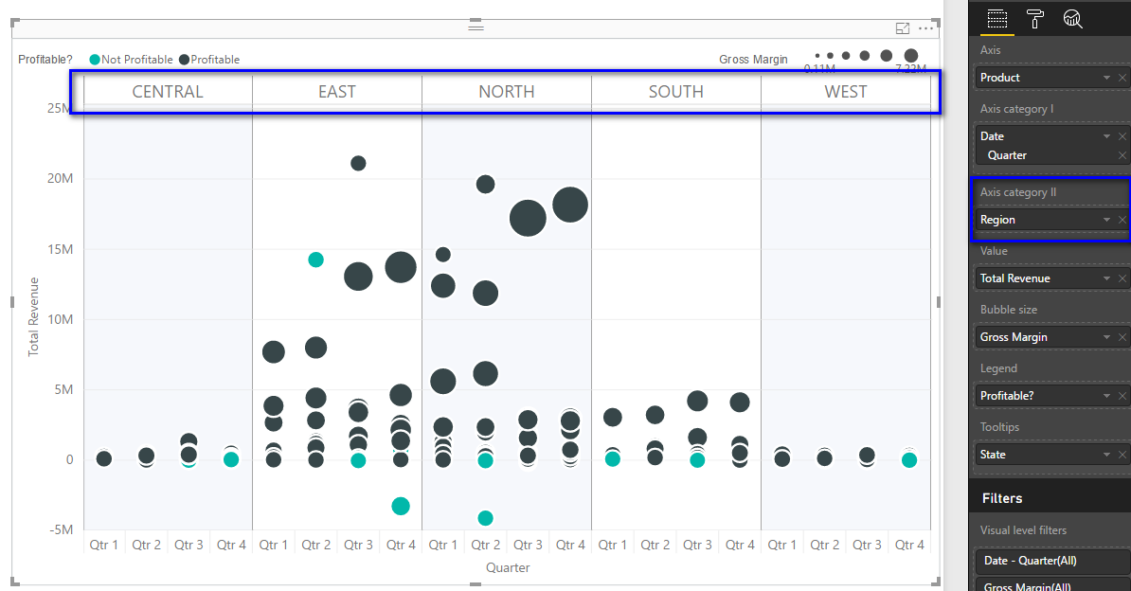

If a table is included in the report along with the dot plot page will look like below:

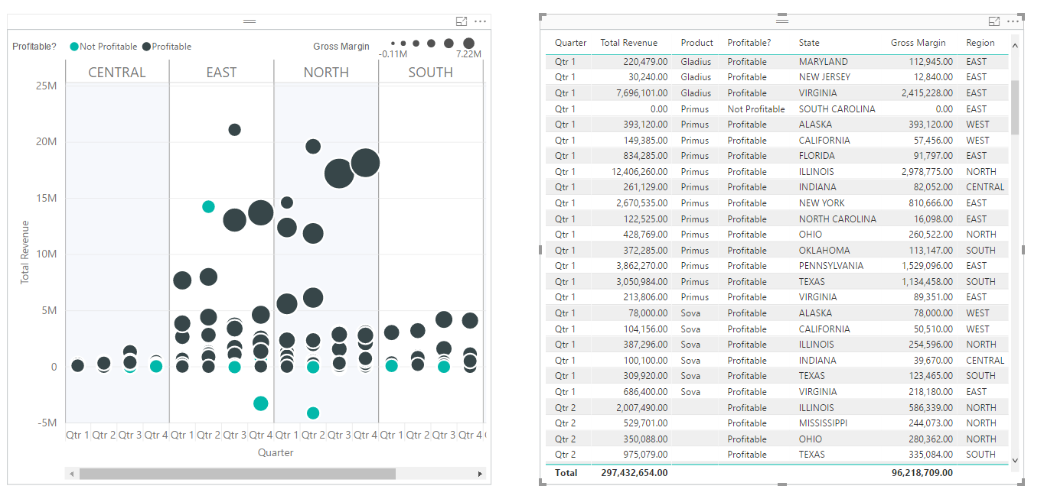

User can filter data either by clicking on bubble or on other visuals (in this case table visual)

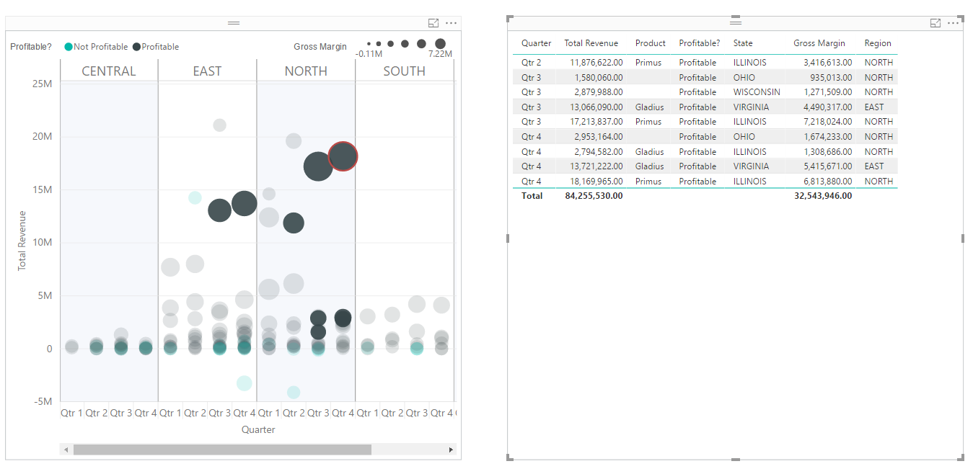

Now the visual can be formatted using different options in Format pane like:

1. Using orientation, the overall visual orientation can be changed from vertical to horizontal

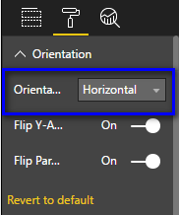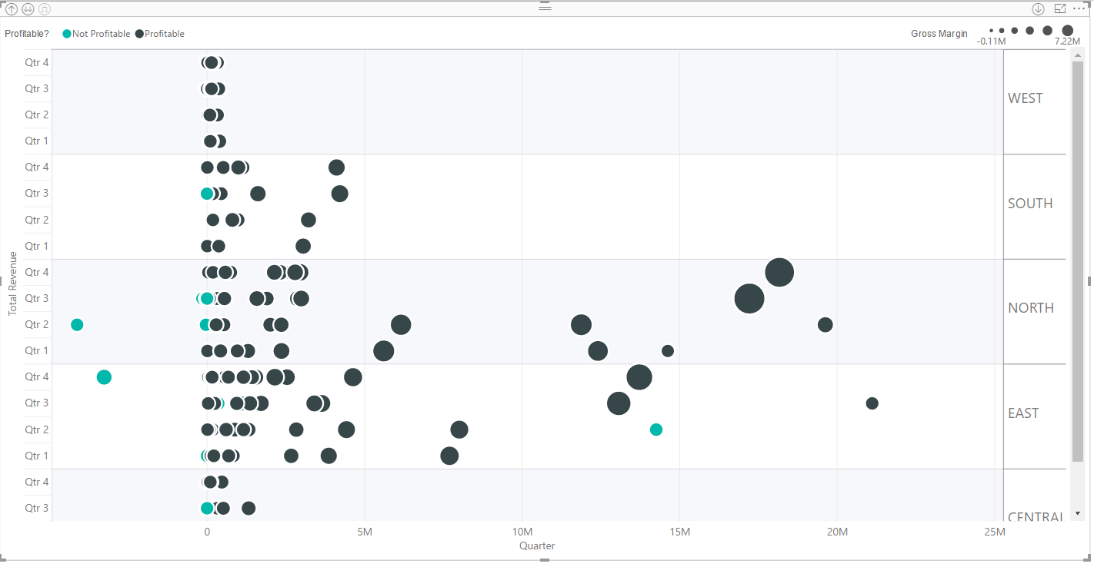

1. In ‘horizontal’ orientation, the orientation of Y axis labels and Parent labels can be flipped.

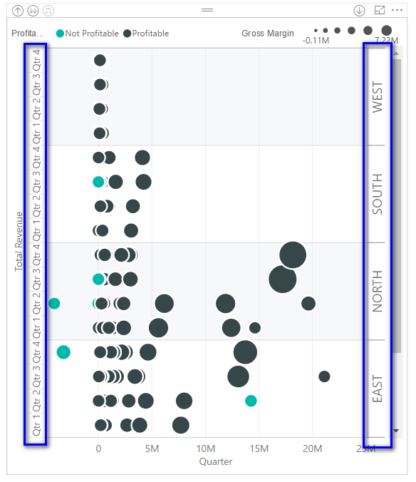 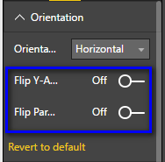

1. Formatting option for Y-Axis:
   1. Title, title text, Title color, Title font size can be updated.

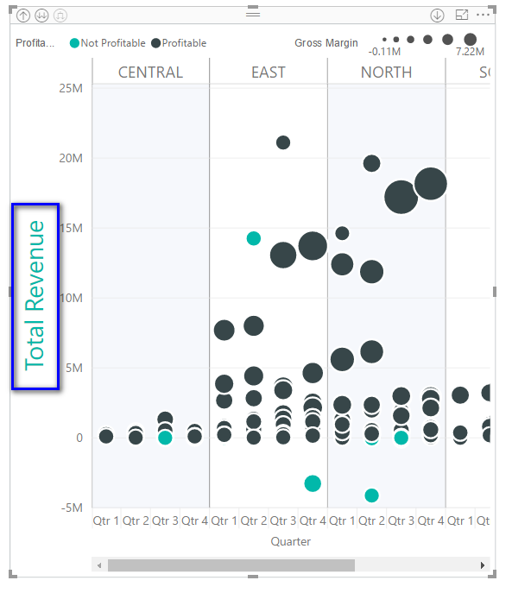 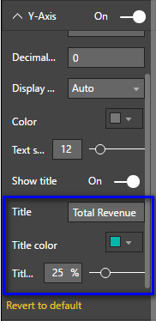

* 1. Display units, decimal points, color and font size of labels can be updated.

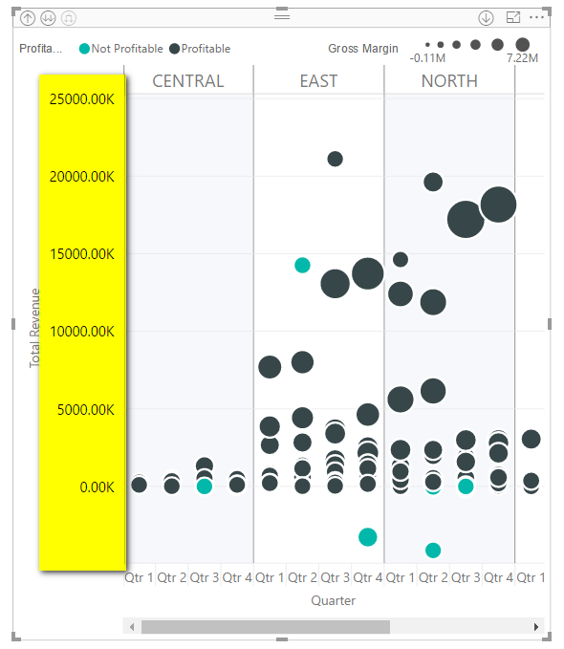 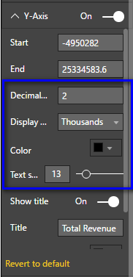

* 1. The Y-axis start, and end values can be changed, so no magnitude comparison can be done, without having to start the y-axis from 0.

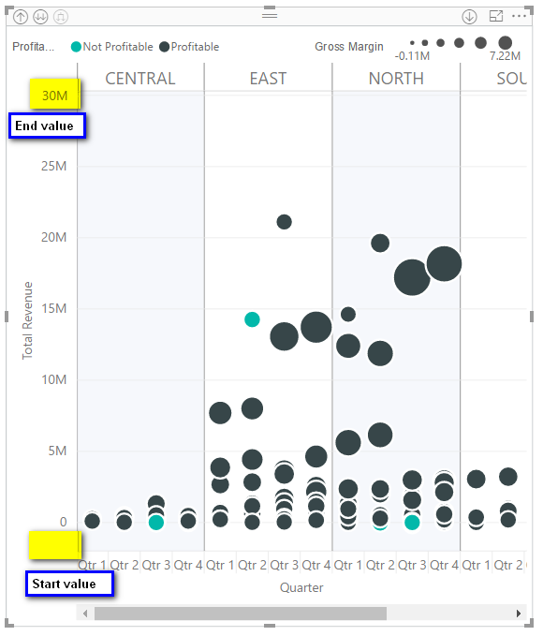 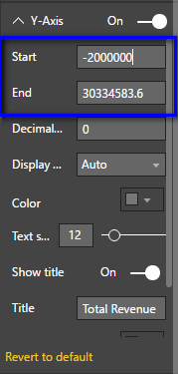

1. Similar options are available for X-axis. Also, minimum width of each X axis label can be configured. After updating the width if the labels cannot be accommodated, horizontal scroll bar appears.

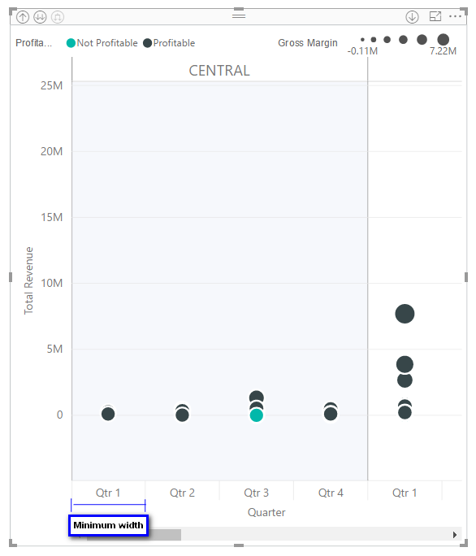 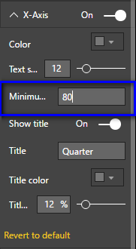

1. Using ‘Axis category’ settings, Axis category II labels can be flipped from top to bottom. The color and font size also can be updated. 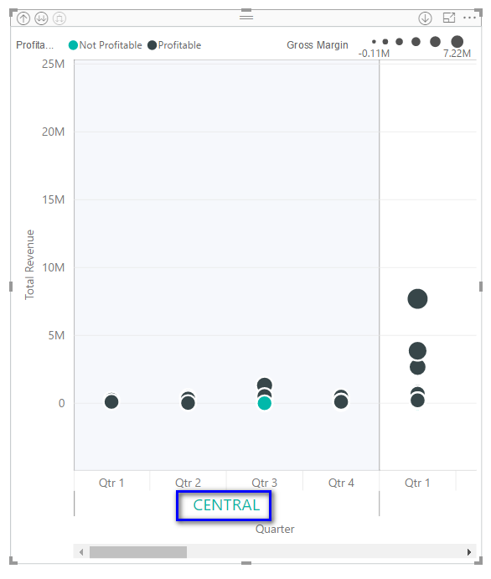 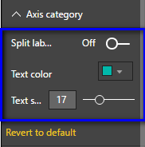
   1. In case of ‘Horizontal’ orientation, Axis category II labels can be flipped from right to left.

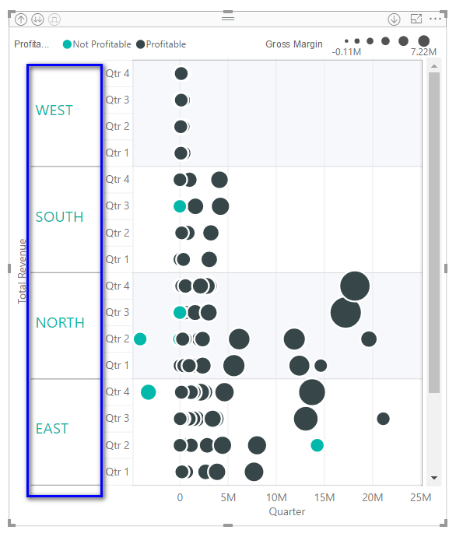 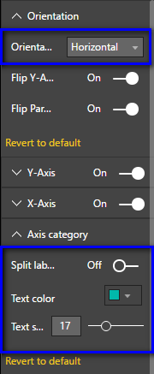

1. The primary and secondary colors of the graph can be modified along with the transparency.

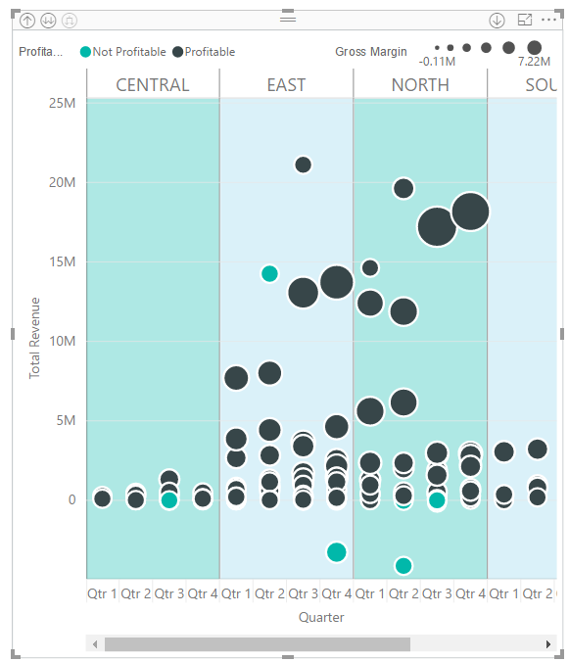 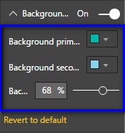

1. The axis and category tick marks can be shown or hidden. The color, thickness of axis and category tick marks can be updated. Similar options are available for grid lines as well.

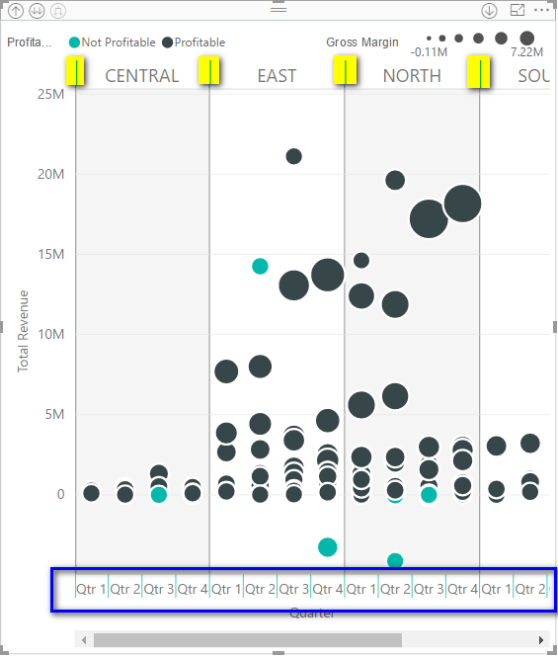 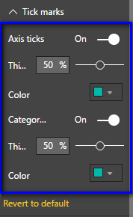

1. The radius range, hover color and transparency of the bubble according to the category.

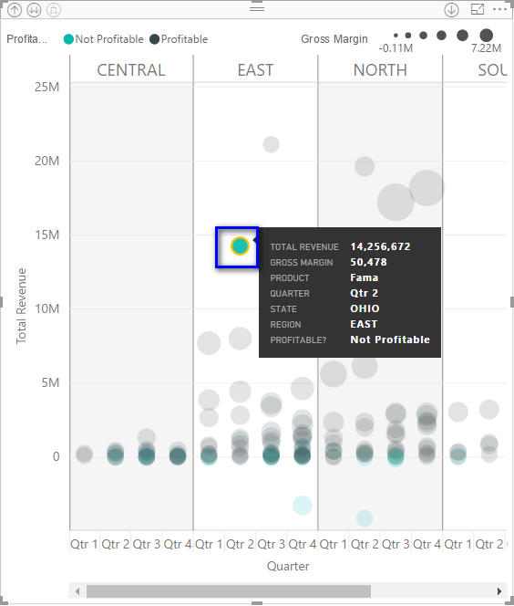 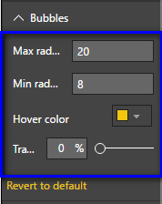

1. Legend positions, font color, font size, title text can be updated.

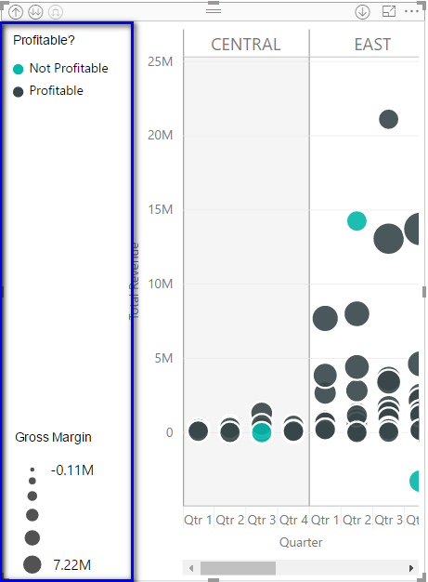 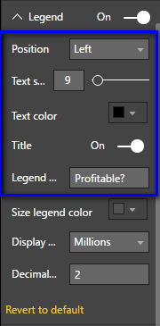

* 1. The color, display units and decimal places of size legends can be updated.

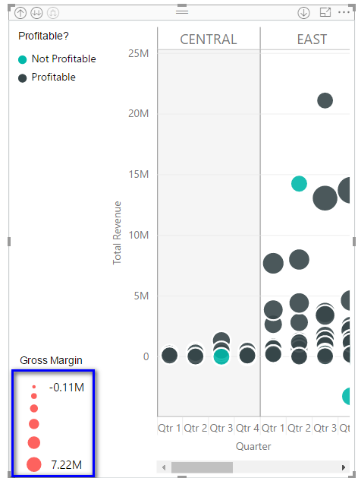 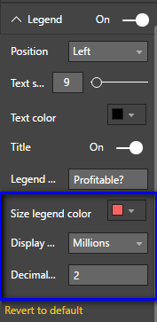

1. If a measure is selected instead of category in ‘Legend’ field, legend disappears and Gradient colors option will appear. The color of each bubble will be a different gradient ranging from minimum to maximum color provided in the ‘Gradient colors’ option.

